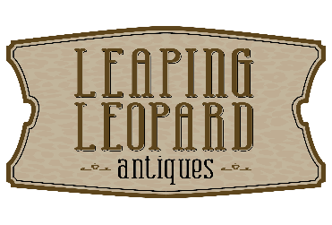
Tips for Sellers
Yes, we buy antiques and vintage items!

Please call or text Heather at (765) 426-4111. Items for sale will be reviewed by the owners of the shop and then possibly shared with other dealers.
You may also e-mail photos and details to leapingleopardllc@gmail.com

Some advice….
- Please understand that we CANNOT offer you retail price for your items. We are re-sellers, and we strive to at least double our money most of the time.
- Please also understand that what you see an item listed for on eBay is NOT necessarily what we will sell it for in our shop. In addition, you are likely seeing an item’s LIST price, not for the SOLD FOR price. An item’s VALUE is sometimes much different than its RETAIL VALUE.
- Please also consider that an item might sell for more in California or even Illinois than it will in Lafayette, IN.
- We do NOT offer official appraisals. We can only advise you on the current market value, based on what we know sells here locally at what price point, based on our experience.
- If you really do not plan to sell, please do not use us to price your items.
- Dishes and glassware, especially clear glass, is hard to sell and will likely not be purchased.
- ALL SELLERS MUST PROVIDE A VALID DRIVER’S LICENSE OR OTHER FORM OF ID.
- We also occasionally sell items from the public on consignment. Please see any of our sales associates for details.

